Title: Home Network Topology Design and Explanation.
Introduction:
The Design of my home network topology where multiple devices are connected using both wired and wireless communication. The network follows a star topology with a central router.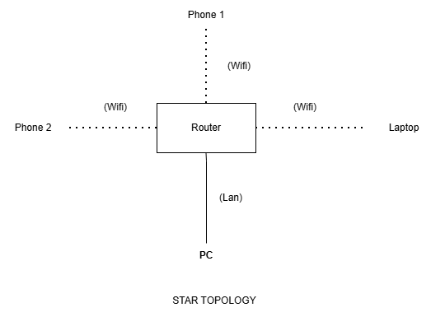
Network Connection Types:
The image clearly shows two distinct types of connections linking the end devices to the central router, differentiated by the type of line drawn:

Wireless Connections (Wi-Fi)

Visual Representation: Shown as dotted lines.

Connected Devices: Phone 1, Phone 2 and the Laptop are connected to the router wirelessly. This means they are using radio waves (Wi-Fi) to communicate with the router.

Wired Connection (LAN)

Visual Representation: Shown as a solid line.

Connected Devices: The PC (Personal Computer) is connected directly to the router using a physical, wired Local Area Network (LAN) connection. This typically represents an Ethernet cable plugged directly into both devices, providing a highly stable connection for a stationary device.

Component Explanations:

Internet Service Provider (ISP): This is the external network (Wide Area Network or WAN) that provides global internet connectivity to the home.

Modem: The modem acts as a translator. It converts the analog signal coming from the ISP (via cable, fiber, or phone lines) into a digital signal that the home network can understand, and vice versa.

Wireless Router: This is the central hub of the home network. In a typical home setup, this is a "3-in-1" device that acts as:

Router: Routes traffic between the local home network and the public internet. It assigns private IP addresses to devices using DHCP.

Switch: Provides physical ports for wired connections.

Wireless Access Point (WAP): Broadcasts the Wi-Fi signal so mobile devices can connect without cables.

End Devices (Clients): These are the devices consuming the network services.

Desktop PC: Connected via a physical cable for maximum stability and speed.

Smartphones & Laptops: Connected wirelessly for mobility and convenience.

Advantages:
- Easy to install and manage
- Failure of one device doesn’t affect others
- High performance with dedicated connections
Disadvantages:
- If router fails → entire network stops
- More dependency on central device

